

MATHEMATICS
YEAR 8 - PATHWAY 2

Investigation 1 – Smooth Fractions
Semester 1 2019

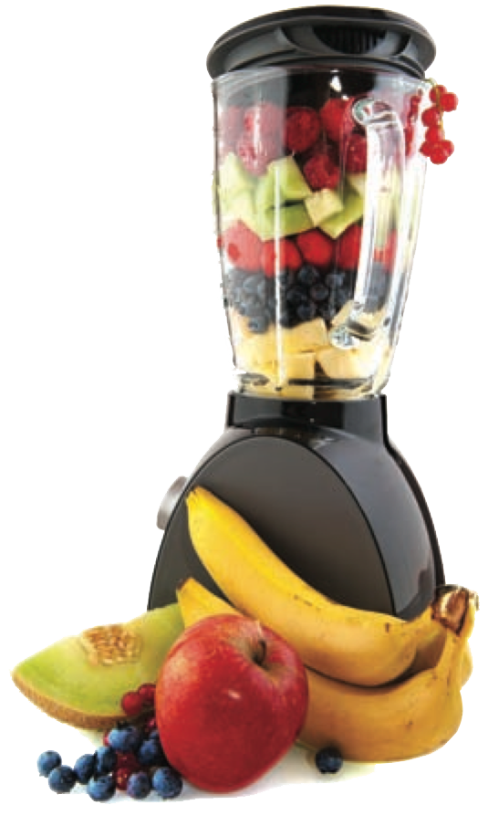

Information for Students

Validation component working time: 40 minutes
Marks available: 30 marks
CALCULATORS ALLOWED: Mobile phones are to be placed in bags at the front of the classroom.
The take home component must be handed in. Failure to hand this component in at the start of the validation will result in a loss of 10% of the overall validation component mark.

Part A
Focus: To calculate fractional quantities for the ingredients in smoothie recipes.
Situation: Paris’ brother, Michael, and his friend, Kevin, join Nikki, Jenna and Paris at Nikki’s house. Everyone wants a ‘Power Smoothie’. The ingredients Paris needs for 1 serve are listed below.
Power Smoothie
Serves 1 person
Ingredients
• 1½ bananas
• 2¾ tablespoons skim milk powder
• 1¼ cups of milk
• 1 tablespoon honey
• ½ cup thick yoghurt

.
- (7 marks)
Calculate the amount of each ingredient required to make two Power Smoothies for Michael and Kevin. Include units in all your answers.
3 bananas - 1 mark for value correct
5 ½ tbsp skim milk powder - 1 mark for value correct
2.5 or 2 2/4 or 10/4 cups milk - 1 mark for value correct
2 tbsp honey - 1 mark for value correct
1 cup yoghurt - 1 mark for value correct
At least 4 units given correctly – 2 marks
Give 1 mark if only units are correct. Follow through marks available if x wrong

- (8 marks)
Find the amount of each ingredient needed to make Power Smoothies for all the people at Nikki’s house. Include units in all your answers.
5 x - 1 mark
7.5 bananas - 1 mark for value correct
13 3/4 or 55/4 tbsp skim milk powder - 1 mark for value correct
6 1/4 or 25/4 cups milk - 1 mark for value correct
5 tbsp honey - 1 mark for value correct
2 ½ or 5/2 cup yoghurt - 1 mark for value correct
At least 4 units given correctly – 2 marks
Give 1 mark if only units are correct. Follow through marks available if x wrong

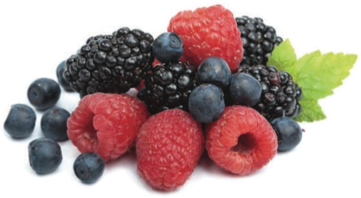

Part B
Focus: To explore the four operations on fractions within the real-life context of picking fruit.
- (4 marks)
Raspberries are collected and placed in 18 kg boxes. They are then packed into ¾ kg punnets or 1¼ kg punnets.
How many of the following sized punnets can be packed from the 18 kg box of raspberries?
- ¾ kg [2]
24

- 1¼ kg [2]
14

- (4 marks)
  - Which of the above sized punnets results in raspberries being left over in the box? [2]
1 ¼

  - How many kilograms are left? [2]
0.5kg

The next day, James and Jenny collect blueberries and placed them in a box. They then packed them into ¾ kg punnets.
When finished, they had 18 punnets and ½ kg of blueberries left in the box.
- (7 marks)
  - How many kilograms of blueberries did the box hold? [3]
13.5 (2 marks) + 0.5 = 14 kg (1 mark)

  - Could they pack this amount of blueberries into ½ kg punnets without any left overs? Explain your answer. [2]
Yes (1 mark) and a good explanation why (1 mark)

  - Could they pack this amount (answer of Question 5) of blueberries evenly into 1¼ kg punnets? Explain your answer. [2]
No (1 mark) – only 11 whole punnets, remainder doesn’t divide evenly (1 mark)

End of Validation

